AI Assited coding Assignment-7.1: Error Debugging with AI: Systematic approaches to finding and fixing bugs
Name:Kanneboyina Meghana
batch-44
HTNO:2303a52345
Task 1 (Syntax Errors – Missing Parentheses in Print Statement)
Prompt: Provide a Python snippet with a missing parenthesis in a print
statement (e.g., print "Hello"). Use AI to detect and fix the syntax error
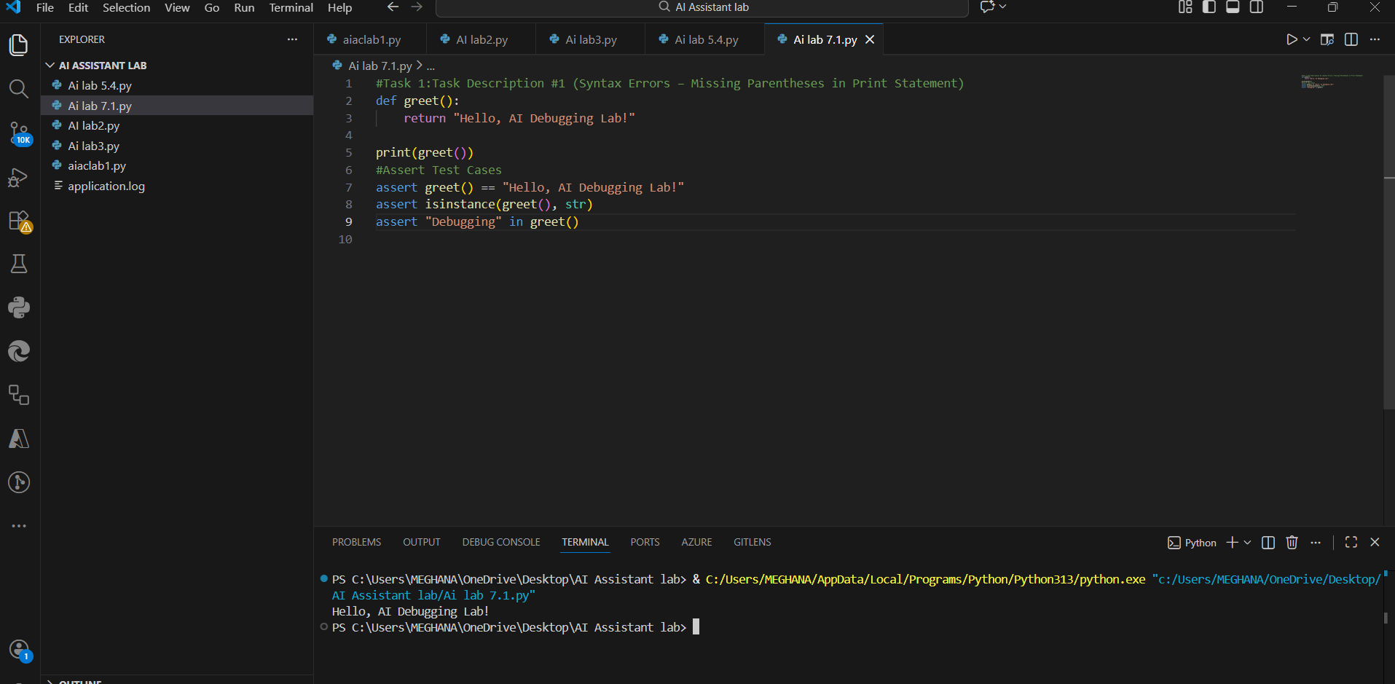
Explanation:
1.The program gives a syntax error because print is used without parentheses.
2. In Python 3, print is a function, so parentheses are required.
3.The interpreter stops execution and shows a syntax error message.
4.AI detects the issue and suggests using print() correctly.
5.After fixing the syntax, the program runs successfully.
6. Assert statements are used to verify the correctness of the output.
Task 2: (Incorrect condition in an If Statement)
Prompt: Supply a function where an if-condition mistakenly uses =
instead of ==. Let AI identify and fix the issue.
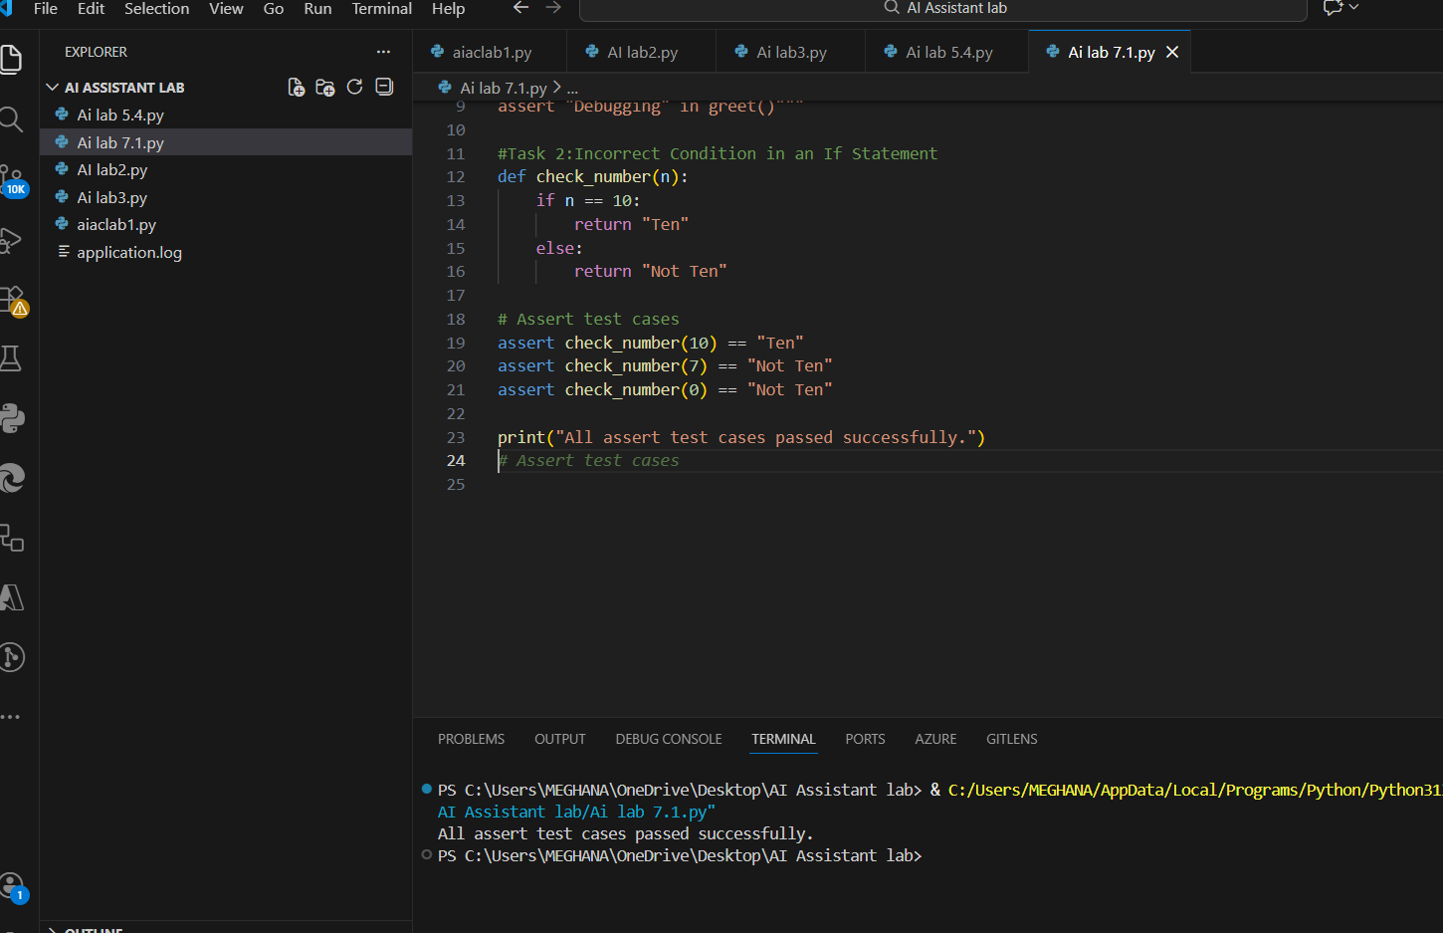
Explanation:
1.The operator = is used for assignment, not comparison.
2.The operator == is used to compare values.
3.Using = inside an if condition causes a syntax error.
4. AI detects the mistake and suggests replacing = with ==.
5. After correction, the function works correctly.
6.Assert test cases confirm successful execution.
Task 3: (Runtime Error – File Not Found)
Prompt: Provide code that attempts to open a non-existent file and crashes. Use AI to apply safe error handling.
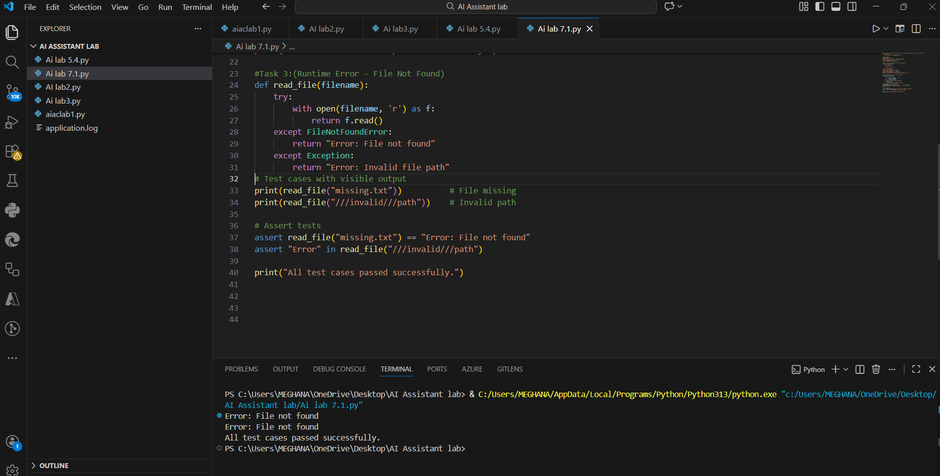
Explanation:
1. The program crashes because it tries to open a file that does not exist.
2. Python raises a FileNotFoundError, which is a runtime error.
3.AI suggests using a try–except block to handle this exception safely.
4.This prevents the program from crashing and allows a user-friendly message.
Task 4: (Calling a Non-Existent Method)
Prompt: Give a class where a non-existent method is called (e.g., obj.undefined_method()). Use AI to debug and fix.
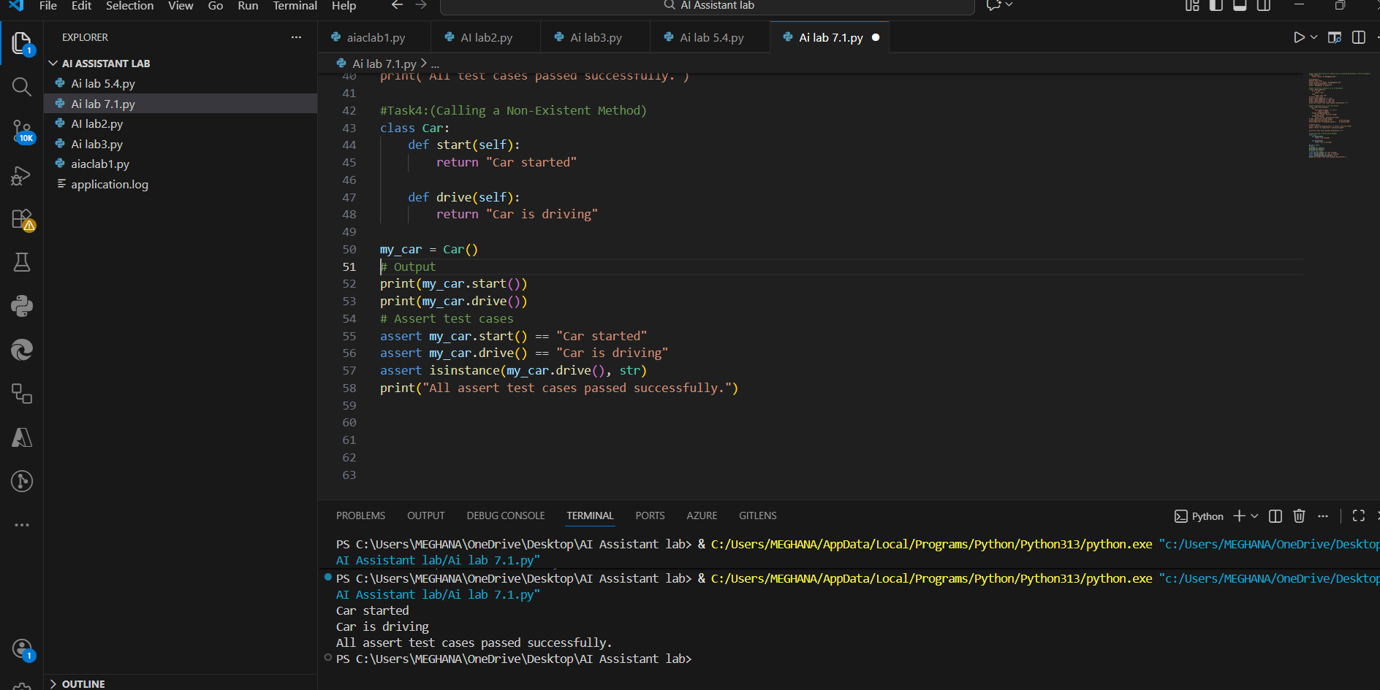
Explanation:
1. The method drive() is called, but it is not defined in the Car class.
2. Python raises an AttributeError when an undefined method is accessed.
3.AI analyzes two possible fixes:
4.Define the missing drive() method
5.Correct the method call to an existing method
6.In this case, defining the missing method is the best fix.
Task 5: (TypeError – Mixing Strings and Integers in Addition)
Prompt: Provide code that adds an integer and string ("5" + 2) causing a TypeError. Use AI to resolve the bug
1.Type casting
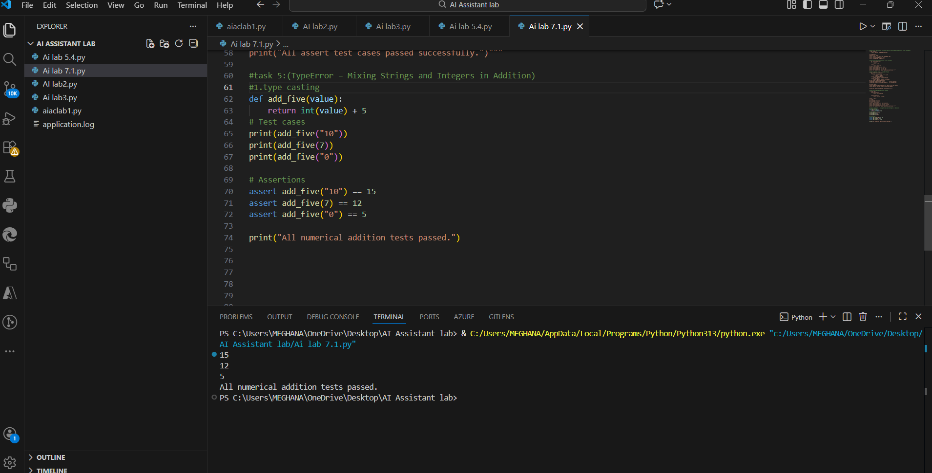
2.string concatenation:
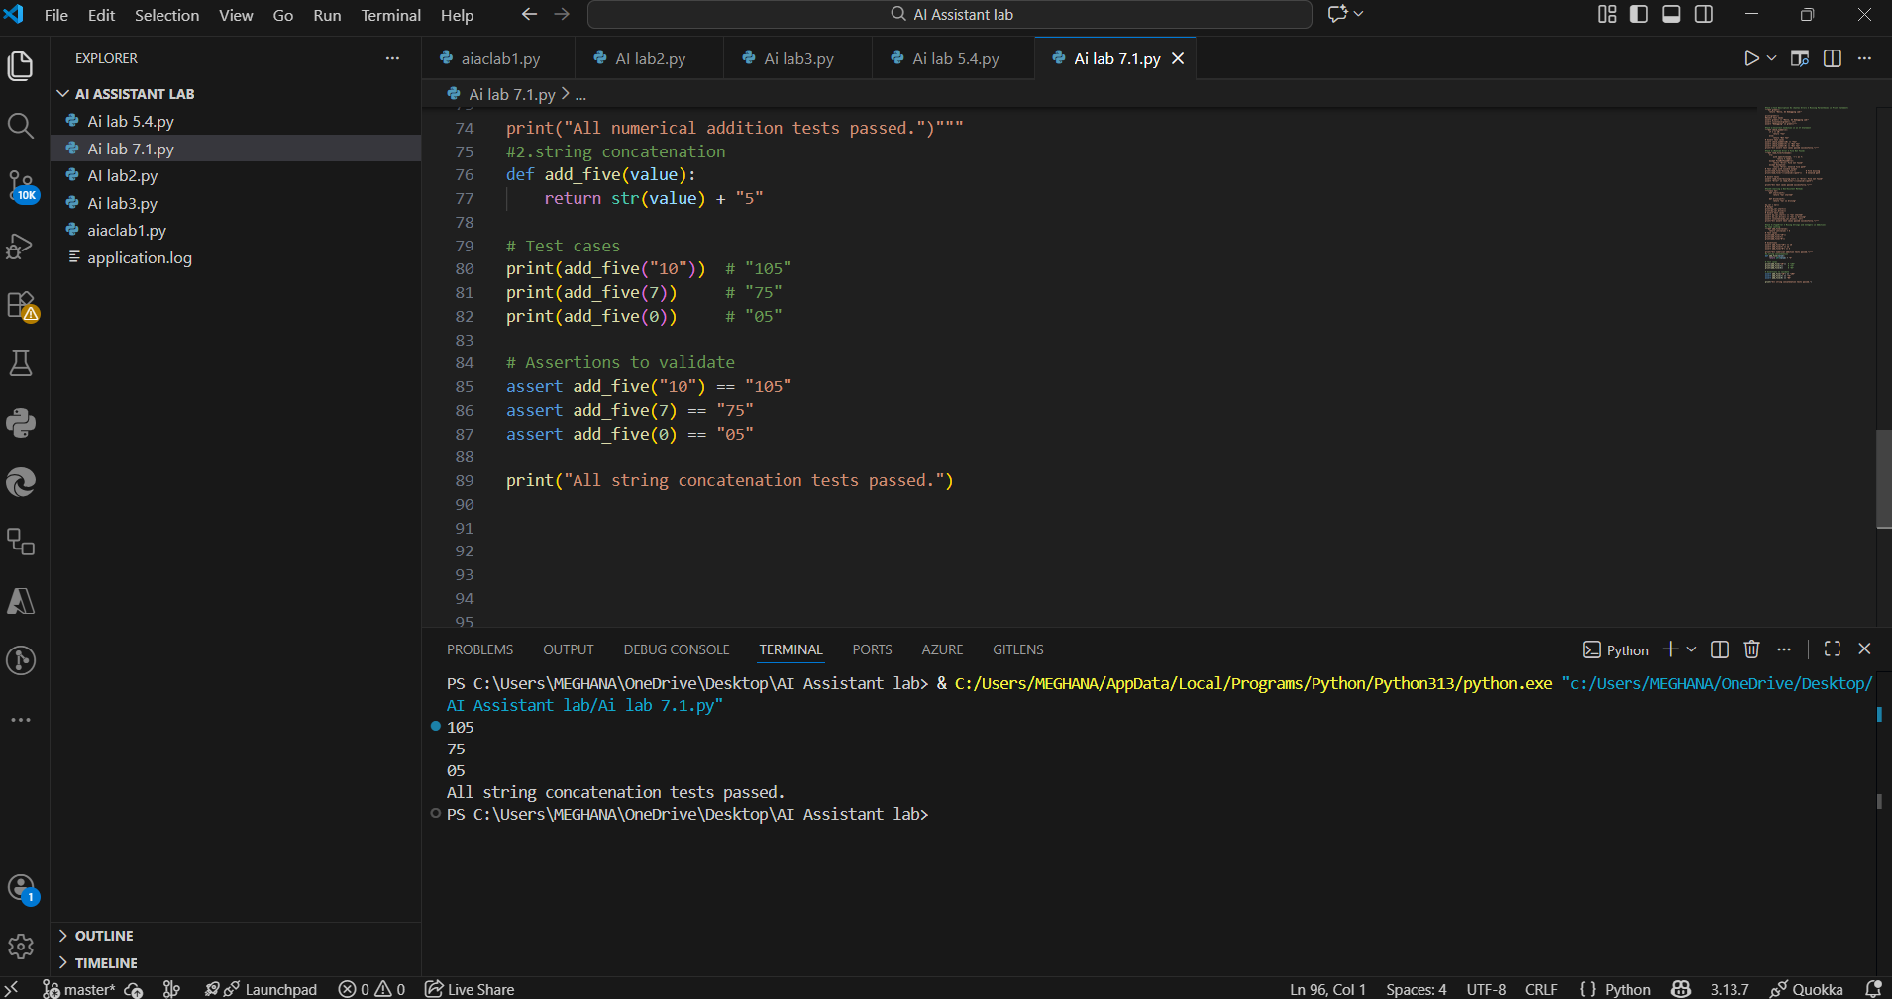
Explanation:
1. The TypeError occurs because the code tries to add a string ("10") and an integer (5).
2.Python does not allow mixing data types for addition.
3. AI suggests two solutions:
- Type casting: Convert the string to an integer for numeric addition.
- String concatenation: Convert the integer to a string and join as text.
4. Using assert statements ensures the function works correctly for multiple inputs.

